**PART-A (About 2-3 Pages)**

**Format for Micro-Project Proposal**

**For 1st to 4th Semester**

**Title of Micro Project:**

1. **Brief Introduction: (Importance of the Project, in about 4 to 5 sentences)**

The project is about music player which helps user to listen multiple songs hassle-free. It has a simple interface with which user can interact easily. The player uses songs on the local device which is accessed with the help of database. With this software users can enjoy their favorite melodies.

**2.0 Aim of the Micro Project (in about 4 to 5 sentences)**

Aim: To design music player using Visual basic language and .NET framework and connect it to a database and create a simple user interface which consists of list of songs, player, etc.

**3.0 Action Plan (Sequence and time required for major activities for 8 weeks)**

|  |  |  |  |  |
| --- | --- | --- | --- | --- |
| **Sr. No.** | **Details of Activity** | **Planned**  **Start Date** | **Planned**  **Finish Date** | **Name of Responsible Team Members** |
| 1 | Topic Selection |  |  | All |
| 2 | Research |  |  | All |
| 3 | Report Writing |  |  | All |
| 4 | Creating software |  |  | All |

**4.0 Resources Required (Such as raw material, some machining facility, software etc.)**

|  |  |  |  |  |
| --- | --- | --- | --- | --- |
| **Sr. No.** | **Name of Resource/Material** | **Specifications** | **Qty** | **Remarks** |
| 1 | Visual Studio | 2019 | 1 |  |
| 2 | MS Word | 2019 | 1 |  |
| 3 | MS Access | 2019 | 1 |  |
| 4 | Internet | ----------------- | - |  |

Annexure-IA

**PART-B (Outcomes after Execution and Format for Micro-Project Report, About 6-10 Pages)**

**For 1st to 4th Semester**

**Title of Micro Project:**

1. **Brief Description: (Importance of the project, in about 100 to 200 words)**

The project is about music player which helps user to access multiple songs hassle-free. It has a simple interface with user can interact easily. The player uses songs on the local device which is accessed with the help of database. With this software users can enjoy their favorite melodies

because of its simple usable interface.

1. **Aim of Micro Project: (in about 100 to 200 words)**

Aim: To design music player using Visual basic language and .NET framework and connect it to a database and create a simple user interface which consists of list of songs , player, etc.

1. **Course Outcomes Integrated (Add to the earlier list if more CO’s are addressed)**

**a.** Use Visual Studio IDE to design application.

**b.** Develop GUI Application using Form Controls and its events.

**c.** Use Data access controls to store data in Database and retrieve it.

**d.** Use Data Binding in GUI Application

1. **Actual Procedure followed**

* Choosing the right project was imperative which required the most time.
* Research was done on the project requirements and resource requirement
* Gathered the knowledge of UI designing and database connectivity
* Team members communicated their requirements and created a basic prototype of the user interface and designed the database accordingly
* After making the UI, the main logic was written
* Testing of the project was done regularly and bugs where fixed.
* The paper work was divided.

1. **Actual Resources Used: (Mention the actual resources used)**

|  |  |  |  |  |
| --- | --- | --- | --- | --- |
| **Sr. No.** | **Name of Resource/Material** | **Specifications** | **Qty** | **Remarks** |
| 1 | Visual Studio | 2019 | 1 |  |
| 2 | Ms-Word | 2019 | 1 |  |
| 3 | Ms-Access | 2019 | 1 |  |
| 4 | Internet | ----------------- | - |  |

1. **Outputs of the Micro Projects**

Music List:

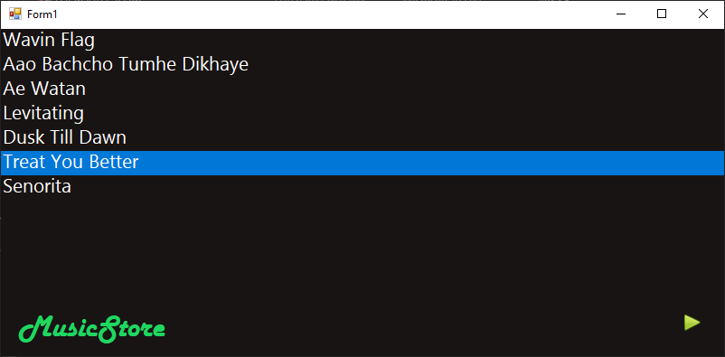

Player:

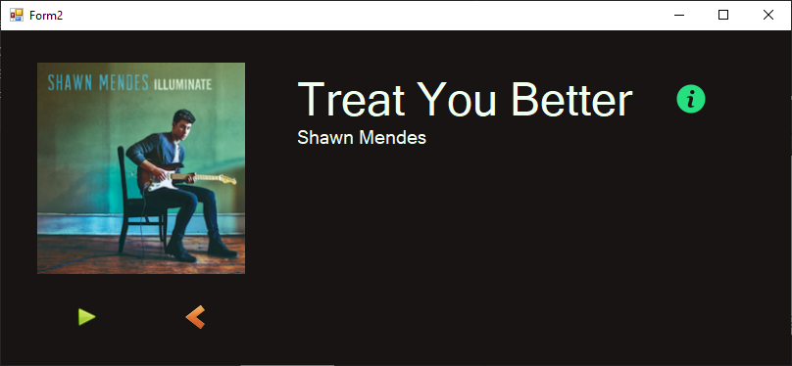

Details in player

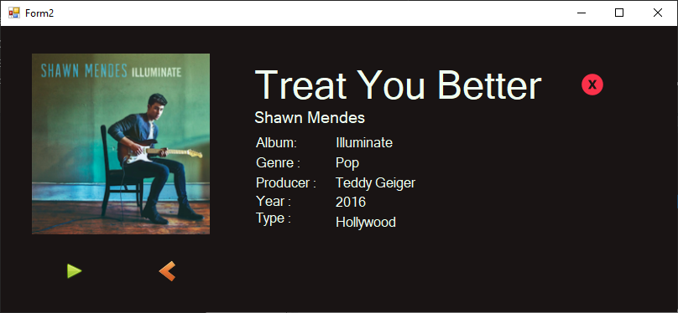

1. **Skill Developed/Learning out of this Micro Project**

* Learnt how to build page layout and interact with front-end.
* Developed user interfaces for database-driven windows applications
* Designed a logical and efficient user interface for technologically-naive consumers.
* Learnt the value of professionalism
* Developed team work skills like leadership, listening skills, critical thinking and problem solving.

.

Annexure-IIA

**Name of Student:** Anurag Dubey **Enrollment No:** 1905680013

**Name of Programme:**  Computer Engg. **Semester:iV**

**Course Title:** GAD **Code:**22034

**Title of the Micro Project:** Music Player

**Course Outcomes Achieved:**

**a.** Use Visual Studio IDE to design application.

**b.** Develop GUI Application using Form Controls and its events.

**c.** Use Data access controls to store data in Database and retrieve it.

**d.** Use Data Binding in GUI Application

**Micro Project Evaluation Sheet**

|  |  |  |  |  |
| --- | --- | --- | --- | --- |
| **Process Assessment** | | **Product Assessment** | | **Total**  **Marks 10** |
| **Part-A**  **Project Proposal**  **(Mark-2)** | **Project**  **Methodology**  **(Mark-2)** | **Part-B**  **Project Report/**  **Working Model**  **(Marks-2)** | **Individual**  **Presentation/**  **Viva**  **(Marks-4)** |
|  |  |  |  |  |

**Note: Every course teacher is expected to assign marks for group evolution in first 3 columns and individual in 4th columns for each group of students as per rubrics.**

**Comments/Suggestions about team work/leadership/inter-personal communication (if any)**

**----------------------------------------------------------------------------------------------------------------------------**

**Any other Comments:**

**----------------------------------------------------------------------------------------------------------------------------**

**Name and Designation of Faculty Members**

**Signature:**

**Name of Student:** Vinay Savla **Enrollment No:** 1905680016

**Name of Programme:** Computer Engg**. Semester:** IV

**Course Title:** GAD **Code:**22034

**Title of the Micro Project:** Music Player

**Course Outcomes Achieved:**

**a.** Use Visual Studio IDE to design application.

**b.** Develop GUI Application using Form Controls and its events.

**c.** Use Data access controls to store data in Database and retrieve it.

**d.** Use Data Binding in GUI Application

**Micro Project Evaluation Sheet**

|  |  |  |  |  |
| --- | --- | --- | --- | --- |
| **Process Assessment** | | **Product Assessment** | | **Total**  **Marks 10** |
| **Part-A**  **Project Proposal**  **(Mark-2)** | **Project**  **Methodology**  **(Mark-2)** | **Part-B**  **Project Report/**  **Working Model**  **(Marks-2)** | **Individual**  **Presentation/**  **Viva**  **(Marks-4)** |
|  |  |  |  |  |

**Note: Every course teacher is expected to assign marks for group evolution in first 3 columns and individual in 4th columns for each group of students as per rubrics.**

**Comments/Suggestions about team work/leadership/inter-personal communication (if any)**

**----------------------------------------------------------------------------------------------------------------------------**

**Any other Comments:**

**----------------------------------------------------------------------------------------------------------------------------**

**Name and Designation of Faculty Members**

**Signature:**

**Name of Student:** Sahil Makhijani **Enrollment No:** 1905680020

**Name of Programme:** Computer Engg. **Semester:** IV

**Course Title:** GAD  **Code:22034**

**Title of the Micro Project:** Music Player

**Course Outcomes Achieved:**

**a.** Use Visual Studio IDE to design application.

**b.** Develop GUI Application using Form Controls and its events.

**c.** Use Data access controls to store data in Database and retrieve it.

**d.** Use Data Binding in GUI Application

**Micro Project Evaluation Sheet**

|  |  |  |  |  |
| --- | --- | --- | --- | --- |
| **Process Assessment** | | **Product Assessment** | | **Total**  **Marks 10** |
| **Part-A**  **Project Proposal**  **(Mark-2)** | **Project**  **Methodology**  **(Mark-2)** | **Part-B**  **Project Report/**  **Working Model**  **(Marks-2)** | **Individual**  **Presentation/**  **Viva**  **(Marks-4)** |
|  |  |  |  |  |

**Note: Every course teacher is expected to assign marks for group evolution in first 3 columns and individual in 4th columns for each group of students as per rubrics.**

**Comments/Suggestions about team work/leadership/inter-personal communication (if any)**

**----------------------------------------------------------------------------------------------------------------------------**

**Any other Comments:**

**----------------------------------------------------------------------------------------------------------------------------**

**Name and Designation of Faculty Members**

**Signature:**

**Name of Student:**Kuber Dhure **Enrollment No:** 1905680053

**Name of Programme:** Computer Engg. **Semester:**IV

**Course Title:** GAD **Code:** 22034

**Title of the Micro Project:** Music Player

**Course Outcomes Achieved:**

**a.** Use Visual Studio IDE to design application.

**b.** Develop GUI Application using Form Controls and its events.

**c.** Use Data access controls to store data in Database and retrieve it.

**d.** Use Data Binding in GUI Application

**Micro Project Evaluation Sheet**

|  |  |  |  |  |
| --- | --- | --- | --- | --- |
| **Process Assessment** | | **Product Assessment** | | **Total**  **Marks 10** |
| **Part-A**  **Project Proposal**  **(Mark-2)** | **Project**  **Methodology**  **(Mark-2)** | **Part-B**  **Project Report/**  **Working Model**  **(Marks-2)** | **Individual**  **Presentation/**  **Viva**  **(Marks-4)** |
|  |  |  |  |  |

**Note: Every course teacher is expected to assign marks for group evolution in first 3 columns and individual in 4th columns for each group of students as per rubrics.**

**Comments/Suggestions about team work/leadership/inter-personal communication (if any)**

**----------------------------------------------------------------------------------------------------------------------------**

**Any other Comments:**

**----------------------------------------------------------------------------------------------------------------------------**

**Name and Designation of Faculty Members**

**Signature:**